EXPERIMENT- 8
1.
# Dataset
employee <- data.frame(
EmployeeID = c(1,2,3),
Department = c("Sales","HR","Marketing"),
YearsOfService = c(5,3,7),
PerformanceScore = c(85,92,78)
)

# Line Chart
plot(employee$EmployeeID,
employee$PerformanceScore,
type = "o",
col = "blue",
pch = 16,
lwd = 2,
main = "Employee Performance Trend",
xlab = "Employee ID",
ylab = "Performance Score")

legend("topright",
legend = "Performance Score",
col = "blue",
lty = 1,
pch = 16)
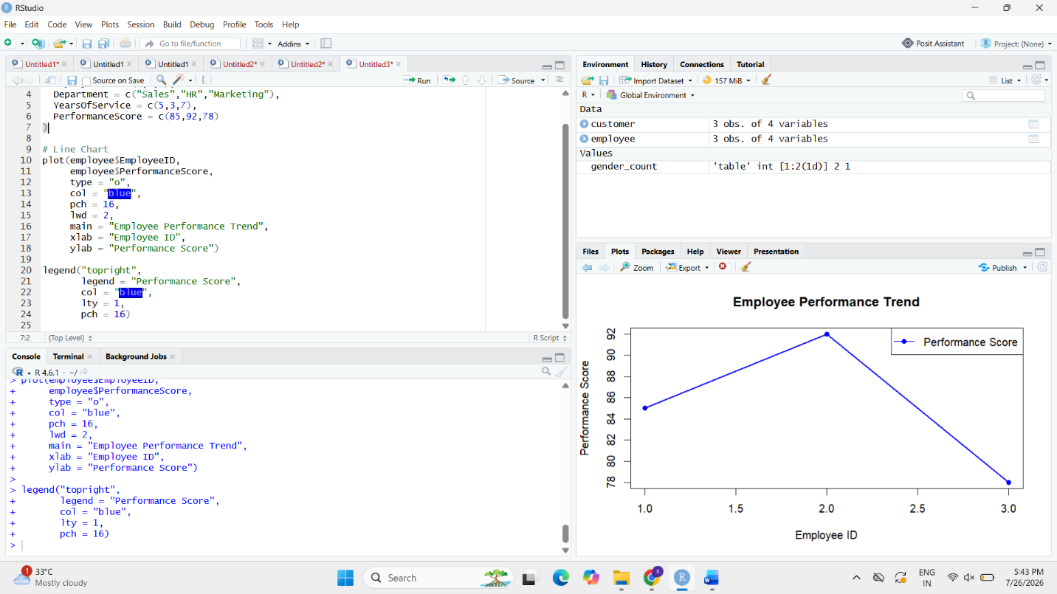

2.
# Dataset
employee <- data.frame(
EmployeeID = c(1,2,3),
Department = c("Sales","HR","Marketing"),
YearsOfService = c(5,3,7),
PerformanceScore = c(85,92,78)
)
# Department Count
dept_count <- table(employee$Department)
# Bar Chart
barplot(dept_count,
col = c("red","green","blue"),
main = "Employees by Department",
xlab = "Department",
ylab = "Number of Employees")

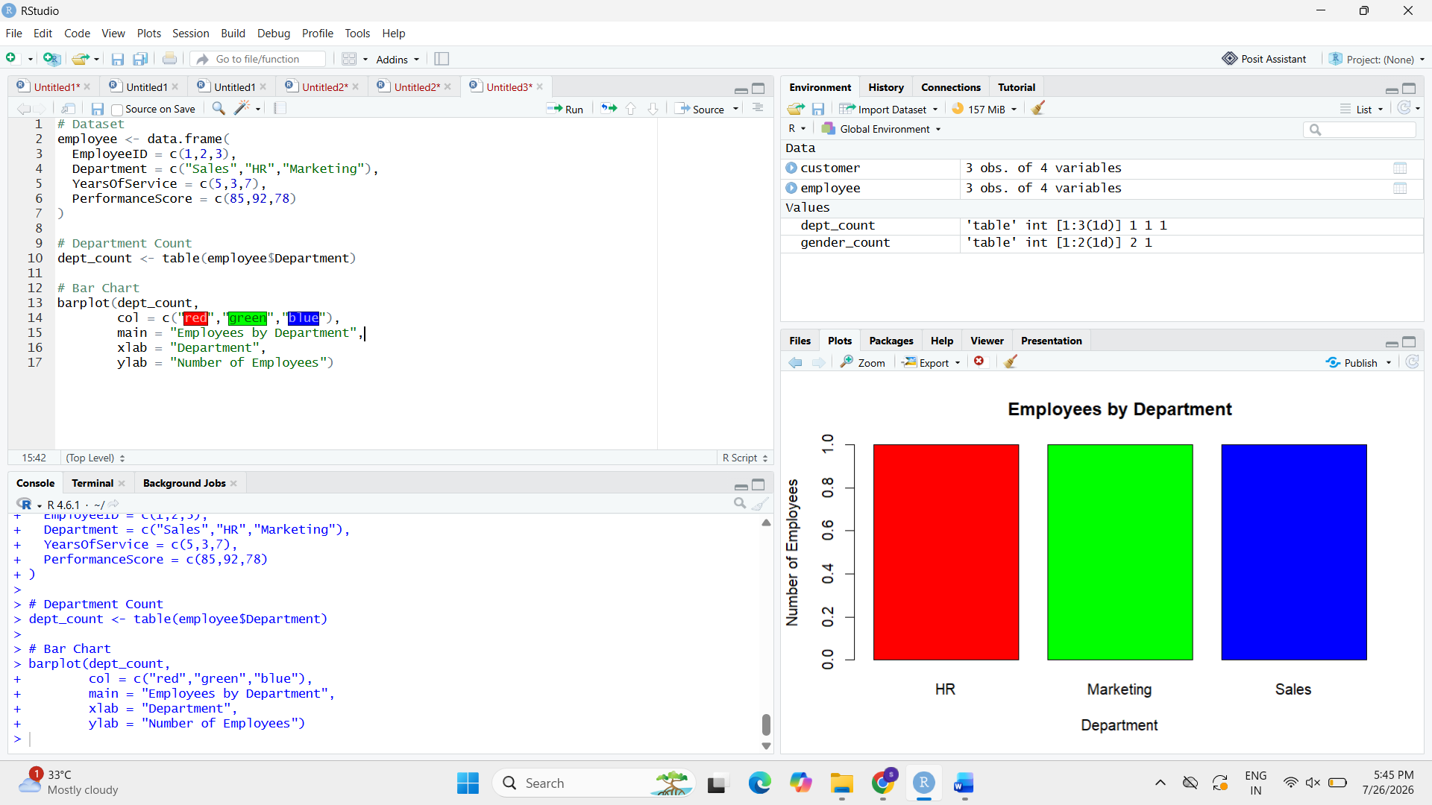
3.
# Dataset
employee <- data.frame(
EmployeeID = c(1,2,3),
Department = c("Sales","HR","Marketing"),
YearsOfService = c(5,3,7),
PerformanceScore = c(85,92,78)
)

# Display Table
print(employee)

